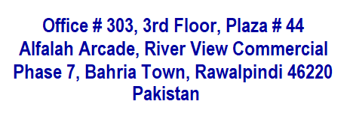

**Technological Consultants – Appraisers – Indenters - Engineering - Aerospace & Avionics Services – Importers - Suppliers of Specialized Items & Material**

**Soan Air Land Technologies is a platform, managed by a team of professionals and business management experts. Specialisations include technical and technological consultancy, engineering solutions, aircraft assessments, aircraft maintenance services including overhauling, procurement of specialised material and components as well as business management consultancy.**

**Introduction**

**Soan Air Land Technologies is a subsidiary of the 2012-founded Soan Group of Companies. This enterprise is a platform that is managed by a group of professionals and business management experts. We serve diverse clientele, including government institutions, law enforcement agencies, and the private sector.**

**About Us**



* **Engineering Solutions**

**Areas of Operation**

* **Technical and Technological Consultancy**
* **Aircraft Appraisal**
* **Aircraft Maintenance including Overhauling**
* **Aviation and Industrial Spare Parts including Lubricants**
* **Procurement & Supply of Specialized Material**
* **Procurement & Supply of Specialized Components and Devices**
* **Business Management Consultancy**
* **Transfer of Technology, where required**

**Areas of Business**

* **Aviation Industry**
* **Space Industry**
* **Material Sciences**
* **Chemical Industry**
* **Appraisal Services**
* **Weapons and Equipment**
* **Communications and IT**
* 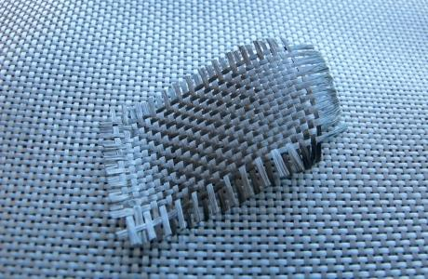A picture containing battery

  Description automatically generatedA helicopter flying over a field

  Description automatically generated with medium confidence**Professional Consultancy (in diversified fields)**

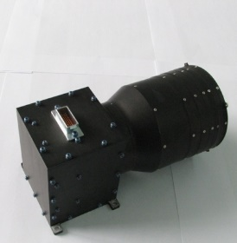

* **Aviacompektacia, Russia**
* **International Bureau of Aviation (IBA), United Kigdom**

**Principals**

* **AeroremService, Russia**
* **SpecServise, Ukraine**
* **Sino Flying Video Hi-Tech Ltd, China**
* **Shenzhen Novel Fiber Tech Co Ltd, China**
* **Henan Shenjiu Tianhang New Material Co. China**
* **SUPARCO**

**Clientele**

* **Aviation Flight (RW), Govt of Punjab**
* **VIP Flight, KPK**
* **VIP Flight, Balochistan**
* **Advance Computing & Engineering Solutions (Pvt) Ltd**
* **AeroWorld Pakistan (Pvt) Ltd**
* **Appraisal / Desktop Valuation of Aircraft**

**Services**

* **Consultancy relating to Technological Upgradation / Adoption**
* **Liaison with OEMs / ARPs / Facilities for Overhauling of Aircraft Aggregates including Engines**
* **Plasma Coating**
* **Aircraft / Helicopter Aggregate Spares**
* **Aviation Grade Lubricants**

**We Supply**

* **Communication Equipment including Antennas, Transmitters etc**
* **Specialized Equipment like Fiber Optic Gyros, Exciter, Encoders, Sensors etc**
* **Stand Alone Gadgets of Aircraft**
* **Specialized Material like Quartz Fiber and Raisins etc**
* **State of the Art Technology, as per the requirement of Clients**
* **To provide our clients with cost-effective engineering solutions and technical/technological advice.**
* **Provide competent expert services in the aviation business.**
* **Consultation on creating a firm in the private sector to contribute to national development.,**

**Objectives**

* **Purchasing cutting-edge technology, tools, and systems for military establishments, including LEAs**
* **Create suitable settings for clients and OEMs to work to achieve the best results and solutions.**
* **Instilling a culture of evaluation in Pakistan to foster professional business environments**
* **Project management in a variety of technology, engineering, and agri-business disciplines.**
* **Improve Pakistan’s technological complexion through the method of Technology Transfer.**
* **Developing long-term business partnership with our clients and OEMs**
* **Facilitating the end user and OEMs to enter into lasting relationship in the field of technology**
* **Earning clients’ confidence through committed interaction and meeting the requirements**

**Aims**

* **Ensuring quicker and dependable services to our clientele**
* **Freeing our clientele from the hassles of imports**
* **Working in close collaboration with our Principals / OEMs**
* **Integration of all facets of our specialists to ensure inspirational and exceptional outcome**

**CEO**

**TUFAIL AHMAD**

**WhatsApp: +923005345222**

**WeChat: SALT_Pakistan**

**Linkedin: linkedin.com/in/tufial-ahmad-50244465**

|  |  |  |
| --- | --- | --- |
| ***Location*** | ***Contact Information*** | |
| **Office # 303, 3rd Floor,**  **Plaza # 44, Alfalah Arcade, River View Commercial,**  **Phase 7, Bahria Town,**  **Rawalpindi 46220** **Pakistan** | **Tel:**  **Fax:**  **Mobile:**  **eMail:**  **Web:** | **+92518770026**  **+92515172164**  **+923005345222**  [info@soanairland.com](mailto:info@soanairland.com)  **www.soanairland.com** |

**Pictorial Database**

